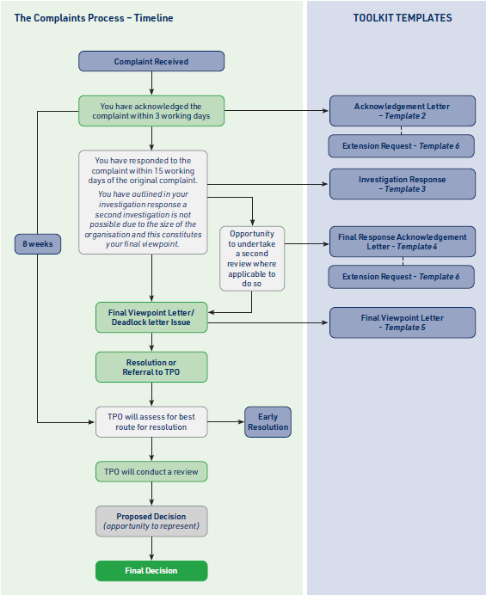
Dear,_________________________(Complainants name)

RE:_____________________________________________________________________

____________________________________________________________________(Property Address)

Thank you for your email/letter dated___________(date), we are sorry you are dissatisfied with the service provided.

We appreciate you raising your concerns and___________________(company name/member of staff) will

provide a formal investigation into your complaints by_________(date). If you would like to discuss the issues

you have raised with us by telephone, we would be happy to schedule time to do so.

I understand the issues you would like me to investigate are_________________________

________________________________________________________________________(list of issues raised).

Please confirm these are the issues/complaints you have raised or contact me within 48 hours if this is not the case.

In the meantime, we would welcome thoughts on what would resolve the issues/complains you have raised.

Should more time be required to investigate the issues

raised________________________________(member of staff name) will contact you to explain why.

It is never our intention to give our customers anything other than an excellent customer experience and I am sorry you have felt this was not the case for you this time.

To refresh you about how we will deal with complaints and the steps involved, I have enclosed a copy of our internal Complaints Procedure.

Please take the time to read this.

Thank you for your patience.

Yours sincerely

______________________________ (Name)

______________________________(Job Title)

Dear,_______________________________(Complainants name)

RE:_____________________________________________________________________

__________________________________________________________________(Property Address)

Thank you for your email/letter of___________________ (date), raising your complaint to us.

Having considered the issues you have raised with us, I have summarised below what I understand your specific complaints to be and what you feel would resolve the matter for you:

• A ___________________________________

• B ___________________________________

• C ___________________________________

• D ___________________________________

If there are any issues you feel have not been covered above, please let me know within 48 hours so I can address these complaints too.

Based on the evidence available to me, I have concluded that:

Please explain the company’s position with regard to the complaints listed above. Include any resolution (financial or otherwise as appropriate) where possible. You may like to enclose supporting evidence of your argument if appropriate.

I would like to offer our sincere apologies that you felt the service provided to you fell below the standards expected of us. I have taken on board all of your comments and will use this feedback to review our procedures, practices and service levels and make amends where needed.

I thank you for taking the time to bring these matters to our attention. As a business we welcome all feedback, both negative and positive.

Please be aware that as we are a small business, there are no other staff members available to provide a further review of the issues you have raised. I hope that I have been able to resolve the matter to your satisfaction, however, if you remain dissatisfied with the proposed resolution please let us know and we will provide a secondary review and response to your issues raised.

Yours sincerely

______________________________ (Name)

______________________________(Job Title)

Dear,_______________________________(Complainants name)

RE:_____________________________________________________________________

__________________________________________________________________(Property Address)

Thank you for your email/letter of___________________ (date), in response to our initial investigation into your complaint. We are sorry you are not satisfied with the response received. Customer satisfaction and service provided is something we value and we would like to resolve your complaint.

We will now undertake a second review of your complaint which will be investigated by

____________________________________(name of member of staff) who will provide a final viewpoint letter/deadlock letter on the issues you have raised. As we have mentioned in previous correspondence we are a small business so it may not always be possible for the second review to be investigated by a different individual in the organisation.

This will be provided to you by _______________________________(date).

Should more time be required to investigate the issues raised __________________________(name of member of staff) will contact you to explain why.

To refresh you about how we will deal with complaints and the steps involved, I have enclosed a copy of our internal Complaints Procedure.
Please take the time to read this.

Thank you for your patience.

Yours sincerely

______________________________ (Name)

______________________________(Job Title)

Dear,_______________________________(Complainants name)

RE:_____________________________________________________________________

__________________________________________________________________(Property Address)

Thank you for your email/letter of ____________________(date), regarding your complaint.

My name is _____________________________________(name of member of staff) and I have looked at your subsequent complaint.

We are sorry you have felt the need to escalate your complaint to this stage and that we have not yet been able to resolve the matter. It is never our intention to give our customers anything other than an excellent customer experience and I am sorry you have felt this was not the case for you this time. You can be assured that we take all issues raised to us very seriously.

Having considered the issues you have raised with us, I have summarised below what I understand your specific complaints to be and what you feel would resolve the matter for you:

• A ___________________________________

• B ___________________________________

• C ___________________________________

• D ___________________________________

If there are any issues you feel have not been covered above, please let me know within 48 hours so I can address these complaints too.

Based on the evidence available to me, I have concluded that…

Please explain the company’s position with regard to the complaints listed above. Include any resolution (financial or otherwise as
appropriate) where possible. You may like to enclose supporting evidence of your argument if appropriate.

I would like to offer our sincere apologies that you felt the service provided to you fell below the standards expected of us. I have taken on board all of your comments and will use this feedback to review our procedures, practices and service levels and make amends where needed.
I thank you for taking the time to bring these matters to our attention. As a business we welcome all feedback, both negative and positive.

This represents the final viewpoint of __________________________________________(Company Name).

Please be advised that any goodwill offer made is accepted in full and final settlement. I hope that I have been able to resolve the matter to your satisfaction. If, however, you remain dissatisfied, you have the right to refer your complaint to The Property Ombudsman, details of which can be found below.

The Property Ombudsman
Milford House
43-55 Milford Street
Salisbury
SP1 2BP
01722 333 306
www.tpos.co.uk

Please be aware that you have up to 12 months from the date of this email/letter to refer your complaint to the Ombudsman in writing, although it is preferable that you do so as soon as possible if you wish to pursue this matter further. I have enclosed The Property Ombudsman’s Consumer Guide leaflet for your information.

Yours sincerely

______________________________ (Name)

______________________________(Job Title)

Dear,_______________________________(Complainants name)

RE:_____________________________________________________________________

__________________________________________________________________(Property Address)

Thank you for your email/letter dated _________________________(date), please be assured that the

issues you have raised to us are important and we are currently investigating them.

Unfortunately, as we are a small business we are unable to fulfil a full investigation of your issues raised

within the timescales originally set out. We would be grateful if you would allow us an additional

________________(days required) days to be able to provide you with a suitable response.

Thank you for your patience.

Yours sincerely

______________________________ (Name)

______________________________(Job Title)

